Reforming nuclear safety regulation:

Current challenges in the light of history

Witness seminar
Pompeu Fabra University (UPF), Barcelona
14-15 December 2023

Draft programme

Convenors:
Albert Presas i Puig, (UPF, Barcelona)

Markku Lehtonen (UPF, Barcelona)
Tapio Litmanen (University of Jyväskylä, Finland)

Venue:
UPF Campus de la Ciutadella
Carrer Ramon Trias Fargas, 25-27
08005 Barcelona
Sala polivalent 24.S18

13 December

19.30 Dinner/drinks (optional; for those who arrive early enough; venue to be confirmed later)

14 December

Participating regulators:
- Jukka Laaksonen
- Lamberto Matteocci
- Michael Binder
- Allison Macfarlane

10.00-10.15 Welcome. Presentation of the (HoNESt and) PROMISES project(s) (Markku Lehtonen / Albert Presas i Puig)

10.15-10.30 Presentation of the objectives and the logic of a witness seminar (Markku/Albert)

10.30-11.30 Session 1: Presentations – the professional background of the regulators (chair: Albert Presas i Puig)

11.30-12.00 Coffee break

12.00-13.00 Session 2: Key regulatory challenges throughout the decades (chair: Markku Lehtonen)

13.00-14.30 Lunch

14.30-15.30 Session 3: International organisations and collaboration, including the role of the civil society (chair: Josep Espluga)

15.30-16.00 Coffee

16.00-17.30 Session 4: Current challenges: SMRs, advanced reactors, and nuclear newcomer countries (chair: Tapio Litmanen)

17.30-17.45 Closing

19.30 Dinner
Restaurant Ca La Nuri

15 December

Participating regulators:
- Jukka Laaksonen
- Lamberto Matteocci
- Michael Binder

10.00-11.00 Session 5: Feedback and discussion on the basis of the first day (chair: Markku Lehtonen)

11.00-11.30 Coffee break

11.30-12.30 Documentary: The Atom – A Love Affair

12.30-13.30 Closing discussion, on the basis of the film (with the participation of the director of the film, Vicki Lesley, via Zoom)

13.30- Lunch

On witness seminar as a method

The event will take the form of a "witness seminar", in which a limited number of expert participants are invited to discuss, debate, and even disagree about their reminiscences on themes and events of their common interest and on which they have shared experience. As a method of research, witness seminars are used to supplement and extend other types of material (historical archives, policy documents, expert and stakeholder interviews). The direct testimony of key actors can generate valuable new insights overlooked in the official records, and shed light on issues such as individual motivation, interpersonal dynamics and intellectual and cultural influences. Group interaction can facilitate recollection, and expose key areas of consensus and dissent in the professional field in question.

Themes of the seminar

Our seminar focuses 1) on the historical evolution of nuclear safety regulation over the past decades, and, on the basis of this historical experience, 2) on the current and future challenges of nuclear safety regulation, with particular attention to those related to the possible introduction of small modular reactors (SMRs). We have prepared a list of four general themes for discussion, yet the final decisions on the themes to be discussed will be made according to the wishes and suggestions of the participants.

1. Continuity and change in regulation
- the key turning points that shaped nuclear regulation: e.g. TMI, Chernobyl and Fukushima accidents; fall of the Soviet Union, EU enlargement, institutional/organisational changes in national governments
- How did these moments change your own work and thinking?

2. International cooperation
- Which international organisations were the most crucial in your own work and why?
- How did the role of these bodies change over time and how did these changes affect your work?

3. Institutions, stakeholders, and civil society
- Which role, if any, have the various stakeholders and the civil society played in your own work as safety regulator?

4. Current challenges: SMRs, advanced reactors, and nuclear newcomer countries
- The tensions and opportunities (e.g. public trust in the regulator) involved in regulatory streamlining and harmonisation designed to accommodate SMRs and advanced reactor technologies
- Regulatory harmonisation and capacity-building as countries without previous experience of nuclear technologies seek to adopt nuclear energy (esp. SMRs).
- Regulatory organizations and public opinion in a world of multiple crises, including the declining trust in experts as well as political and economic elites.

The seminar is a continuation to a similar event we organised a few years ago as part of our recent research project, History of Nuclear Energy and Society (HoNESt). In particular, it contributes to our current research project, PROMISES, which focuses on the promise of the SMRs.

On the use of the material collected during the seminar

The data obtained at the seminar will be analysed and used exclusively for scientific purposes. Later on, once we are certain that no sensitive data is revealed, some data may be selected for its use in reports, scientific papers or presentations with a scientific or promotional purpose.
No personal information will be offered to third parties under any circumstances, nor used with any other purpose than this research project. Nevertheless, should you wish so, you of course have the full right to prohibit the use of any information related to you.

We will audio-record and transcribe the seminar discussions, in order to enable the use of this information for our research. We intend to make the full transcript available and downloadable in pdf format on a publicly accessible website. If you wish that one or several of your statements do not appear in the final transcript, you can ask us to interrupt the recording at any time during the seminar. Furthermore, before making the transcript publicly available, we will send it to you in order to allow you to correct any possible errors or misinterpretations concerning the statements attributed to you in the transcript. You may also remove from the transcript part or all of the statements that you have made during the seminar. We plan to use the transcript as background material for scholarly publications and for possible outreach activities.

Should you have any queries, please do not hesitate to contact:

Albert Presas i Puig, tel: +34 680 27 42 49; email albert.presas@upf.edu
Markku Lehtonen, tel: +34 698 08 85 48 (Whatsapp: +358 50 590 3713); email markku.lehtonen@upf.edu

Maps

The seminar venue

University Pompeu Fabra
Campus de la Ciutadella
Ramon Trias Fargas, 25-27
08005 Barcelona
Sala polivalent 24.S18
https://goo.gl/maps/d9zAffGWNAE2

The University residence

Residència d'Investigadors
Carrer de l'Hospital, 64
08001 Barcelona
https://maps.app.goo.gl/ZkWzZkazTateAjsK9

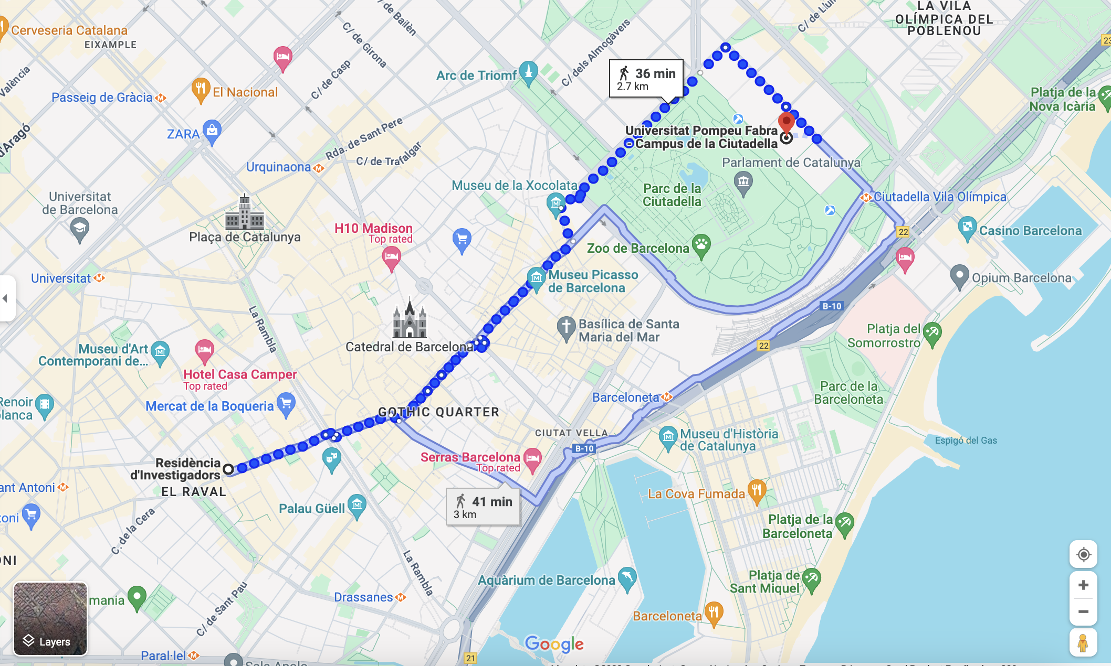

The restaurant

Ca la Nuri
Passeig marítim de la Barceloneta
08003 Barcelona
https://restaurantcalanuri.com/en/
https://goo.gl/maps/5gwhfnTP7ZU2

