UPF REGISTRATION GUIDE FOR EXCHANGE STUDENTS and STAFF*
*Notice:
—You will be addressed as a “student” by the system, even if you are staff.
—We recommend applicants to use Firefox browser

ON-LINE REGISTRATION

To complete an exchange mobility at Pompeu Fabra University, it is necessary that you officially register at UPF. Please, read carefully the following information, and don’t hesitate to contact us if you have any question.

1st GET YOUR IDENTIFICATION CODES
First, you need to get your identification codes by clicking here.
[https://gestioacademica.upf.edu/regi/controlreg/registroPublico?entradaPublica=true&pais=GB&idioma=en&destino=MOV]

- Fill in your personal data on the first screen
- Verify and accept the privacy conditions on the second screen
- We recommend you to print the third screen so that you have your ID and password to access the system

2nd FILL IN THE EXCHANGE STUDENT/STAFF APPLICATION
Once you are registered and you have received an auto-reply e-mail, you can access the registration form by clicking here
[http://secretariavirtual.upf.edu/cosmos/Controlador/?apl=Uninavs&gu=a&idNav=inicio&NuevaSesionUsuario=true&NombreUsuarioAlumno=ALUMOVIN&idioma=en&pais=GB]

1/ ACCESS TO THE FORM
In order to access to the form, you will need to enter your ID (Passport or ID number, as written in the previous step) and password (date of birth using the format ddmmyyyy).

2/ SELECT MOBILITY
Select your MOBILITY:
- ERASMUS+ INTERNATIONAL UG (for undergraduate and master students)
- ERASMUS+ INTERNATIONAL PHD/STAFF (for faculty and doctoral candidate)
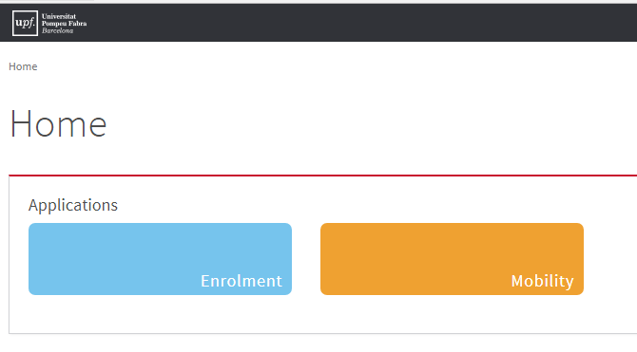 | 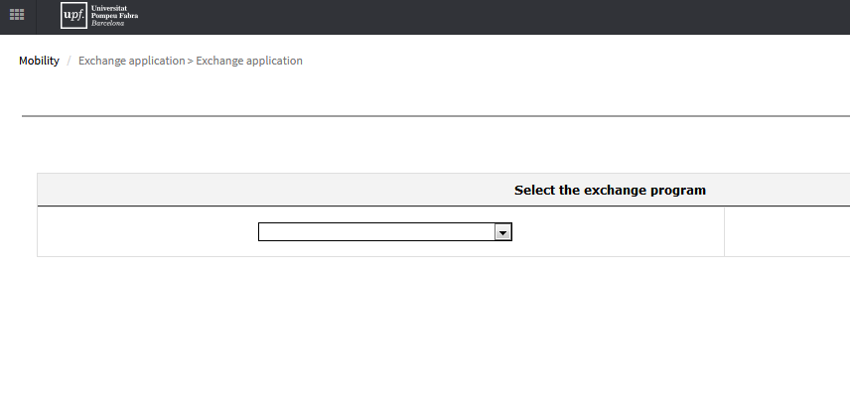
Very important: do NOT select the Study Abroad Program!

3/ FILL IN YOUR PERSONAL DATA
Write correctly all data requested.

4/ FILL IN THE INFORMATION ABOUT THE EXCHANGE AND UP-LOAD YOUR PICTURE AND DOCUMENTS
Picture: the file has to meet the following requirements: JPG format, 176 x 220 pixels at 300ppi. Maximum file size is 75kb. It must be a Passport picture style (without sunglasses or hat).
Documents: In order to complete your registration you have to upload the requested documents (.pdf) according to your Exchange Programme. Some documents are compulsory. If you don’t upload them, you won’t be able to finish the process.
Erasmus + International:
Undergraduate and master: Passport picture, Transcript of records, Learning agreement
PhD and Teaching staff: Passport picture, Curriculum Vitae, Learning or Mobility agreement proposal.

5/ INDICATE YOUR HOME UNIVERSITY
When selecting your home university’s country, you’ll see UPF’s partner universities

6/ SELECT YOUR FACULTY / DEPARTMENT OR SCHOOL AT UPF
Note for undergraduate students (DEGREE): you might see more than one study area, according to the agreement we have with your home university. Please select yours.

Note for PhD or Staff (POSTGRADUATE): you will have to choose the hosting program postgraduate, or the program corresponding to your hosting department or faculty where you are going to teach (Staff).
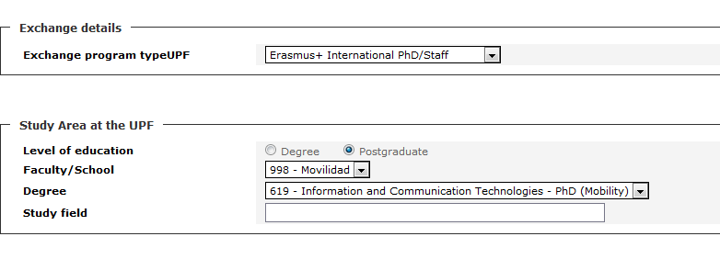
7/ INDICATE YOUR STUDY PERIOD AT UPF
Now, you should specify the duration of your stay, firstly informing us which term or semester you’ll be studying at UPF and secondly, entering the approximate dates of your stay.

8/ SAVE YOUR REGISTRATION
Finally, select “save” and congratulations, you have completed your on-line registration!

9/ CONTACT US IN CASE YOU HAVE ANY QUESTIONS AND TO NOTIFY YOUR SUBMISSION HAS BEEN DONE:
silvia.vilanova@upf.edu

